6.26: The normal force does no work. The work-energy theorem, along with Eq. (6.5), gives
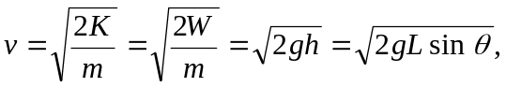

where 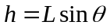 is the vertical distance the block has dropped, and is the angle the plane makes with the horizontal. Using the given numbers,

